STROBE Checklist

**Title and Abstract**

Item No. 1 –

* 1. Use of *cost* in the title indicates this study is estimating the monetary cost of business restrictions, and phrases such as “potential value of therapies”, “cost of these restrictions”, and “societal benefits” in the abstract imply we are measuring the larger monetary cost/value of restrictions/therapies on a societal population.
  2. Abstract provides a summary of our goal (“investigate potential value of therapies addressing COVID hospitalizations”), our methods (“Using high-frequency economic data, we estimate restrictions in the US”), and our results (“reduced consumer spending by $12 billion and increased initial weekly unemployment claims by 114,000”).

**Introduction**

Item No. 2 – Background/rationale

“COVID’s most notable impact has been illness and the loss of lives, but the pandemic has also imposed a substantial societal cost. The economy has grabbed headlines, as cumulative losses during just the first two quarters of 2020 amounted to between 1 and 7 percent of annual GDP across the globe, and approximately 3 percent of annual GDP in the United States.(1) Other societal costs include reduced care for health conditions other than COVID,(2,3) although that impact may have been largely limited to the initial several months of the pandemic.(4) Finally, evidence suggests lost in-person schooling will permanently diminish economic opportunities for today’s students; moreover, the impact is greatest for students from the most disadvantaged backgrounds.(5)The pandemic’s economic costs suggest that COVID-19 medical interventions could confer societal benefits exceeding the value of their health benefits.(6) Based on stock market movements in apparent response to positive news about vaccines in development, for example, one analysis estimated a pandemic-ending therapy to be worth between 5 and 15 percent of total wealth.(7) In the United States alone, that result implies a value ranging from $6 to $17 trillion.(8)Assessing the societal value of COVID therapies that have a less dramatic impact on the population as a whole, such as antiviral treatments(9) and monoclonal antibodies,(10) presents a distinct challenge. These therapies do not directly address population disease transmission and therefore have less potential to return life to “normal”. Instead, they aim to prevent progression to severe disease or speed recovery.”

Item No. 3 – Objectives

“This paper’s aim is to estimate the cost of these restrictions [restrictions enacted by US state and local governments during the COVID pandemic] and hence the potential value conferred by COVID-19 therapies that help avert hospital admissions by preventing progression to severe disease or that speed recovery.”

**Methods**

Item No. 4 – Study Design

“To assess the cost of government-imposed economic restrictions, we combined high frequency economic data, information on the pandemic’s progression (case incidence and mortality), and information about when state governments imposed and lifted restrictions on business activities. Rather than including data from spring, 2020, when the pandemic’s initial onslaught increased unemployment claims and reduced consumer spending to an extent unrepresentative of subsequent periods during the pandemic,(17,18) we instead focused on the fall and winter of 2020-2021.” Beginning of methods section describes key elements of study design early in paper

Item No. 5 – Setting

* Setting: Our research setting focuses on the economies of each state in the United States (particularly looking at their consumer spending and unemployment claims).
* Relevant dates: Our data spans the Fall of 2020 and early winter of 2021. The spending timeline goes from September 15 to December 27, and the Unemployment claims timeline goes from September 19 to December 19. The data is based on weekly observations updating the state of the economies each week and the state of predictor variables.
* Data Collection: We did not directly handle the data collection, but the spending data we accessed was collected by a company called Affinity Solutions that tracks credit card spending data. Our unemployment claims data was tracked by the US Department of Labor Statistics, our COVID-19 data comes from case rates and death rates tracked by the NYtimes, and our state business restrictions data is comes from a NYtimes tracking of different state policies over time.
* “We report the number of observations, mean, and standard deviation for all outcome quantities and all explanatory variables. We stratify the data by the level of regulatory measures in place during that week. As described below (see *Data*), we classify each U.S. state during each week as either “mostly closed” due to government-imposed activity restrictions, or as not “mostly closed.””
* “we… focused on the fall and winter of 2020-2021.”
* “The spending data span the period September 15 to December 27, 2020. Our third outcome, for state $s$ and week $i$, was initial unemployment claims (reported on Thursday of each week) per 100 people in the 2019 labor force (${UE}_{i}^{s}$). This data series spanned the period September 19 to December 19, 2020.“

Item No. 6 – Participants

1. Eligibility Criteria: US States and D.C. with data available for both weekly spending and unemployment claims, as well as weekly COVID-19 case rates and death rates, and available data on their business restrictions put in place during the Fall of 2020 and early winter of 2020.
2. Methods of selection:

“Rather than including data from spring, 2020, when the pandemic’s initial onslaught increased unemployment claims and reduced consumer spending to an extent unrepresentative of subsequent periods during the pandemic,(17,18) we instead focused on the fall and winter of 2020-2021.”

Item No. 7 – Variables

“For time series data reported daily, we computed seven-day moving average values to eliminate weekend-weekday effects. For data representing state totals (e.g., consumer spending and COVID incidence), we normalized by state population size. Outcomes – For state $s$ and week $i$, outcomes include percent change in seasonally adjusted spending on restaurants and accommodations compared to January 2020 (), and percent change in seasonally adjusted total consumer spending compared to January 2020 (). To eliminate weekend and weekday periodicity, we computed seven-day moving average values, as described above. The spending data span the period September 15 to December 27, 2020. Our third outcome, for state and week , was initial unemployment claims (reported on Thursday of each week) per 100 people in the 2019 labor force (). This data series spanned the period September 19 to December 19, 2020. Outcomes data come from the Opportunity Insights COVID-19 Economic Tracker project at Harvard University.(19) Selection of these outcomes reflects the expectation that government restrictions affect consumer spending in general and restaurant dining and accommodations in particular. These impacts, in turn, contribute to higher initial unemployment claims. High frequency data are well suited to assessing restrictions imposed at moderately different times across states and remaining in effect for durations often measured in weeks during the fall and winter of 2020-2021. Moreover, because states imposed and lifted these restrictions only shortly before we conducted our analysis, frequently updated data best cover salient periods. Conventional economic activity datasets, like government estimates of gross domestic product (GDP) growth, undergo updating too infrequently to assess the impact of short-term restrictions and the recent imposition of restrictive government measures. Explanatory variables – As with outcomes, we index explanatory variables by state and week . Our primary explanatory variable of interest, designated , is binary. We classified state businesses as restricted or not restricted based on narrative descriptions of state-level closures maintained by the New York Times, which reported for each day whether businesses in each state were “mostly closed.” (20) Based on review of these narratives, we identified when each state changed from not “mostly closed” to “mostly closed”, or the reverse. Our base case analysis designated business in a state as “restricted” during week if, according to the New York Times database, businesses were “mostly closed” on Monday (for the consumer spending outcomes) or Thursday (for the initial unemployment claim outcome) of that week. We included other explanatory variables in an effort to account for how news about the pandemic might influence voluntary, spontaneous reductions in economic activity. These variables included seven-day average, population-normalized (1) daily new COVID cases (), (2) daily COVID mortality (), (3) the increase in daily new COVID cases over the last two weeks (), and (4) the increase in daily COVID mortality over the last two weeks (${DeltaNewDeaths}_{i}^{s}$). Daily COVID cases and deaths come from the New York Times COVID-19 Repository.(21)”

Item No. 8 – Data sources/measurement

* See data availability statement, and details of measurement included above in Item No. 7

Item No. 9 – Bias

* “We included other explanatory variables in an effort to account for how news about the pandemic might influence voluntary, spontaneous reductions in economic activity. These variables included seven-day average, population-normalized (1) daily new COVID cases (), (2) daily COVID mortality (), (3) the increase in daily new COVID cases over the last two weeks (${DeltaNewCases}_{i}^{s}$), and (4) the increase in daily COVID mortality over the last two weeks (${DeltaNewDeaths}_{i}^{s}$).”
* “**Data:** For time series data reported daily, we computed seven-day moving average values to eliminate weekend-weekday effects. For data representing state totals (e.g., consumer spending and COVID incidence), we normalized by state population size.”
* “All regressions are linear mixed models that account for nesting within state and correlation across observations that are close in time. To account for temporal correlation, the base case model implemented a first-order, autoregressive (lag 1-week) covariance structure. This covariance structure assumes correlation is greatest for observations adjacent in time, with decreasing correlation between observations more distant in time.”

Item No. 10 – Study Size

* We intended to analyze the United States, so we chose to use whatever data was available on all the states/territories within the US borders. This passage below indicates why we chose the state level as our observation unit, because given that most restrictions were put in place by state governments, and most economic and population health data were publicly reported at the state level, it made the most sense both for achieving our research goal and logistically to use state level data.
* “To assess the cost of government-imposed economic restrictions, we combined high frequency economic data, information on the pandemic’s progression (case incidence and mortality), and information about when state governments imposed and lifted restrictions on business activities.”

Item No. 11 – Quantitative variables

* See an excerpt from our data description section below.
* “Outcomes – For state $s$ and week $i$, outcomes include percent change in seasonally adjusted spending on restaurants and accommodations compared to January 2020 (), and percent change in seasonally adjusted total consumer spending compared to January 2020 (). To eliminate weekend and weekday periodicity, we computed seven-day moving average values, as described above. The spending data span the period September 15 to December 27, 2020. Our third outcome, for state and week , was initial unemployment claims (reported on Thursday of each week) per 100 people in the 2019 labor force (). This data series spanned the period September 19 to December 19, 2020. Outcomes data come from the Opportunity Insights COVID-19 Economic Tracker project at Harvard University.(19) Selection of these outcomes reflects the expectation that government restrictions affect consumer spending in general and restaurant dining and accommodations in particular. These impacts, in turn, contribute to higher initial unemployment claims. High frequency data are well suited to assessing restrictions imposed at moderately different times across states and remaining in effect for durations often measured in weeks during the fall and winter of 2020-2021. Moreover, because states imposed and lifted these restrictions only shortly before we conducted our analysis, frequently updated data best cover salient periods. Conventional economic activity datasets, like government estimates of gross domestic product (GDP) growth, undergo updating too infrequently to assess the impact of short-term restrictions and the recent imposition of restrictive government measures. Explanatory variables – As with outcomes, we index explanatory variables by state and week . Our primary explanatory variable of interest, designated , is binary. We classified state businesses as restricted or not restricted based on narrative descriptions of state-level closures maintained by the New York Times, which reported for each day whether businesses in each state were “mostly closed.” (20) Based on review of these narratives, we identified when each state changed from not “mostly closed” to “mostly closed”, or the reverse. Our base case analysis designated business in a state as “restricted” during week if, according to the New York Times database, businesses were “mostly closed” on Monday (for the consumer spending outcomes) or Thursday (for the initial unemployment claim outcome) of that week. We included other explanatory variables in an effort to account for how news about the pandemic might influence voluntary, spontaneous reductions in economic activity. These variables included seven-day average, population-normalized (1) daily new COVID cases (), (2) daily COVID mortality (), (3) the increase in daily new COVID cases over the last two weeks (), and (4) the increase in daily COVID mortality over the last two weeks (). Daily COVID cases and deaths come from the New York Times COVID-19 Repository.(21)”

Item No. 12 – Statistical Methods

* 1. Describe all statistical methods, including those used to control for confounding.

See “Methods” section of paper for expanded analysis description

* 1. Describe any methods used to examine subgroups and interactions

“First, we conducted an analysis limited to the 10 states designated “mostly closed” at some point between September 15 through December 27, 2020 (California, Kentucky, Illinois, Michigan, Minnesota, New Mexico, Oregon, Pennsylvania, Rhode Island, and Washington).”

* 1. Explain how missing data were addressed

Missing values: The original dataset included 750 observations for total consumer spending and for spending on restaurants and accommodations (50 states, 15 weeks). We removed 12 observations because zero reported deaths during the index week meant we could not compute a percent change in deaths over the following two weeks. The 12 missing observations included 1 observation for ME, 10 for VT, and 1 for WY. For initial unemployment claims, the original dataset included 714 observations (50 states plus DC, 14 weeks). We removed 13 observations for the same reason as described above for spending, including 1 observation for ME, 1 for NH, 10 for VT, and 1 for WY. All removed observations come from weeks without restrictions. These missing values represent less than 2 percent of our original sample, and a substantially smaller fraction of U.S. GNP. We therefore took no action to provide values for these missing observations.

* 1. If applicable, explain how loss to follow-up was addressed

Not applicable – there was no loss to follow-up.

* 1. Describe any sensitivity analyses

See “Sensitivity Analysis” subheading under “Methods” section for expanded analysis description

**Results**

Item No. 13 – Participants

* Our study follows outcomes for states, not people, with each observation representing a point in time for a particular state.
* Our descriptive statistics report the number of observations for each outcome, both for weeks WITH and WITHOUT restrictions (the treatment vs. non-treatment arms of our analysis).
* For spending data, we limited data to the period September 15 to December 2020. For initial unemployment claims, we limited data to the period September 19 to December 19, 2020.
* We started with economic data (daily spending and weekly unemployment claims) for the period March 2020 to January 2021 and created our dataset as follows:
  + We restricted the dataset to the date ranges specified above.
  + For spending – we replaced the seven observations from each week with their average, yielding 738 state-specific, weekly average values.
  + For initial unemployment claims – the source dataset reported a single value for each week, yielding a total of 701 values for the period.

Item No. 14 – Descriptive Data

1. Give characteristics of study participants (e.g., demographic, clinical, social) and information on exposures and potential confounders

See descriptive statistics in Table 1 (below)

1. Indicate number of participants with missing data for each variable of interest

See item 12, sub-point (c).

1. Summarize follow-up time

Follow-up extended through the period of observation – see Item 13

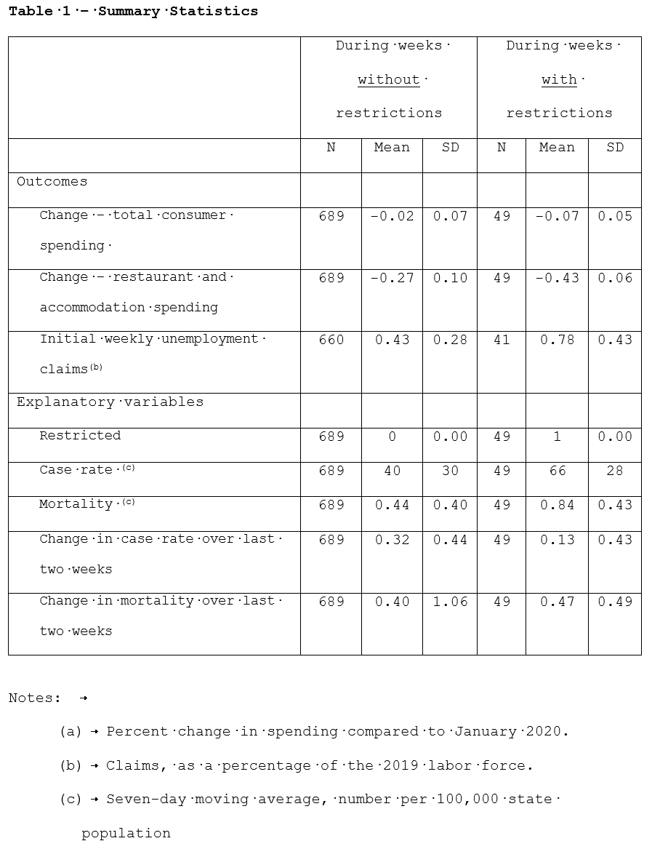

Item No. 15 – Outcome data

* See descriptive statistics under Item 13 for outcomes (total consumer spending restaurant and accommodation spending, Initial weekly unemployment claims rate)

Item No. 16 – Main Results

* See Table 2 (below) and the accompanying text:

“**Base case analysis:** Table 2 reports regression analysis results for our base case models. The estimated impacts of government-imposed restrictions (row labeled “Restricted”) are statistically significant and in the expected direction for all three outcomes – i.e., a reduction in consumer spending, a reduction in restaurant and accommodations spending, and an increase in initial unemployment claims.”

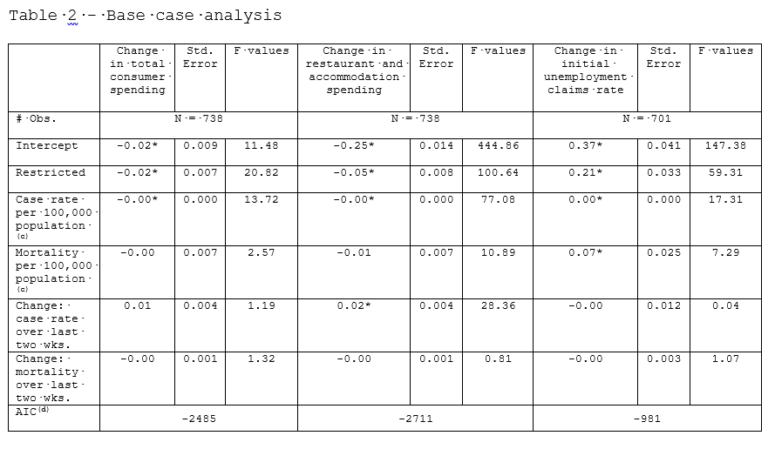

Item No. 17 – Other analyses

* Detailed results for other analyses appear in Tables 3-12 in the manuscript.
* See written description of sensitivities below

**Sensitivity analysis:** Our first sensitivity analysis (Table 3) explored the impact of restricting attention to the 10 states that all experienced periods during which the government imposed restrictions and other periods during which the government did not impose restrictions. For these 10 states, government restrictions had the same impact on total consumer spending (coefficient of -0.02 for Restricted, i.e., a 2 percent reduction) as they had for all 50 states (Table 2). The impacts on restaurant and accommodations spending (coefficient of -0.04 in Table 3 vs. coefficient of -0.05 in Table 2) and on initial unemployment claims (coefficient of 0.20 in Table 3 s. coefficient of 0.21 in Table 2) were slightly smaller than the corresponding impacts in the base case.

Tables 4, 5, and 6 show results for the second set of sensitivity analyses – i.e., for alternative models that do not control for COVID case rate, COVID mortality, or both. The impacts of government restrictions on total consumer spending (Table 4) remain similar to the corresponding base case impacts (coefficient of around -0.02). Impacts on restaurant and accommodations spending (Table 5) likewise remain similar to the corresponding base case impacts (coefficient of around -0.05). For initial weekly unemployment claims (Table 6), not controlling for case rate and death rate modestly increased the estimated impact of restrictions on initial unemployment claims to 0.25 percent of the 2019 workforce from 0.21 percent in the base case.

Tables 7, 8, and 9 present regression model results for the third set of sensitivity analyses, which explore alternative definitions for the $Restricted$ variable. Models designating weeks as $Restricted$ only after two weeks following enactment of state-imposed distancing measures (left panels in Tables 7, 8, and 9) estimated that government restrictions had smaller estimated impacts than the corresponding impacts in our base case model. In Table 7, the left panel coefficient for $Restricted$ is -0.01, compared to -0.02 for the corresponding base case coefficient in Table 2. In Table 8, the left panel coefficient for $Restricted$ is -0.02, compared to -0.05 for the corresponding base case coefficient in Table 2. In Table 9, the left panel coefficient for $Restricted$ is 0.04, compared to 0.21 for the corresponding base case coefficient in Table 2. As detailed in the last rows in Tables 7, 8, and 9, these models had higher AIC values than the base case model, indicating that they do not fit the data as well as the base case model.

Finally, we report results for other model correlation structures (Tables 10, 11, and 12). Not all of the alternative correlation structures we evaluated produced models that converged. For those that did, the estimated impacts of government-imposed restrictions were very similar to or only modestly larger than the corresponding base case estimates. The AIC goodness of fit statistics indicate, however, that models that produced estimates for the impact of government-imposed restrictions that differed the most from the corresponding base case estimates did not fit the data as well as the base case model (larger AIC value).

**Discussion**

Item No. 18 – Summarize Key Results with references to study objectives

* “We found that imposition of government-imposed restrictions during the fall and early winter of 2020-2021 were associated with reduced economic activity. Descriptive statistics revealed lower total consumer spending, lower consumer spending on restaurants and accommodations, and a greater number of initial unemployment claims during weeks with restrictions than during weeks without restrictions (Exhibit 1 – compare outcome means for weeks without and with restrictions). Regression analysis revealed an association with the imposition of restrictions even after controlling for the number of new COVID cases, COVID mortality, and the change in those rates over the preceding two weeks (Exhibit 2, 1st row). That influence appears to be robust to modeling assumptions, as indicated by the modest impact of our sensitivity analyses on the estimated impact of government-imposed restrictions.”

Item No. 19 – Limitations

* “Several factors complicated our assessment of the impact of government restrictions on economic outcomes. Importantly, the nature of the restrictions imposed by state governments differed across states and over time. Our sensitivity analyses using alternative definitions for government restrictions suggest, however, that this issue does not invalidate our findings. A second complication is the fact that government-imposed restrictions tend to coincide with the events that cause voluntary reductions in economic activity. In short, the same news headlines that cause state governments to impose restrictions also cause many consumers to voluntarily stay home and reduce their spending. We attempted to isolate the impact of government-imposed restrictions by including in our models daily COVID cases and mortality, and the changes in those statistics over the preceding two weeks.”

Item No. 20 – Interpretation

* “There remains the issue of characterizing the “real world” importance of our findings. Our base case analysis results imply that restrictions reduce consumer spending by 2 percent, reduce restaurant and accommodations spending by 5 percent, and increase weekly unemployment claims by 0.21 percent of the 2019 work force. Nationally, total annualized consumer spending amounted to $13.3 trillion in the fourth quarter of 2019;(22) restaurant and accommodations spending totals approximately $1.2 trillion annually, including $863 billion spent in restaurants(23) and $300 billion spent on accommodations.(24) The U.S. labor force in 2019 totaled 163 million individuals.(25) The model results hence imply that on an annual basis, restrictions reduce total consumer spending by $2\%×\$13.3 trillion≈\$270 billion$, of which $5\%×\$1.2 trillion=\$60 billion$ can be attributed to a reduction in spending on restaurants and accommodations. The model results also imply that restrictions increase initial weekly unemployment claims by $0.21\%×163 million≈340,000$ initial claims each week. The computations just described yield cost estimates for a hypothetical, nationwide, year-long imposition of business restrictions. We scale these estimates down to characterize the impact of the restrictions actually imposed. During the fall and winter of 2020-2021, when the U.S. experienced the pandemic’s third wave, 10 states (CA, IL, KY, MI, MN, NM, OR, PA, RI, and WA) imposed restrictions for between 21 and 86 days, with an average (and GDP-weighted average) of 49 days. Those states represent approximately one-third of the country’s GDP.(26) Taking a third of the projected nationawide, annual costs (previous paragraph), and then scaling the results down by a further 86.5 percent to impute the costs associated with the imposition of restrictions for 7 weeks (13.5 percent the year) yields costs of $12 billion in total consumer spending, of which $2.7 billion would be attributable to decreased spending on restauraunts and accommodations. Assuming employment is approximately proportional to GDP, these states would together experience an additional 114,000 initial weekly unemployment claims each week during the imposition of these restrictions. (We note that the unemployment data do not reflect seasonal adjustment, but it is not evident that this limitation introduces any particular bias; nonetheless, it does introduce some uncertainty.) While a total cost of $12 billion can seem modest in the context of a global pandemic with estimated costs likely amounting to trillions of dollars in lost economic activity, the losses estimated here are indeed substantial. Keep in mind that they occur over a limited time period (during the 1 or 2 months at the peak of a surge in COVID cases) and that the population can experience multiple case surges during a pandemic; as of this writing, the United States has experienced three such surges). The societal value of therapies that could reduce or even eliminate the need for the most severe restrictions on economic activity could thus run into the tens of billions of dollars, not to mention the reduction in unemployment.”

Item No. 21 – Generalizability

* “Whether prices charged for therapies should reflect this component of value is another question, as decision makers must also consider a range of issues, including affordability.(27) Importantly, this analysis shows that estimating the cost of government-imposed restrictions is feasible, hence making it possible to extend health technology assessments beyond the typical and often exclusive focus on the valuation of health benefits. While a therapy’s health benefits will, no doubt, remain the core element of health technology assessment, for therapies addressing threats that affect others in addition to those who become ill, recognizing societal benefits will help allocate resources to promote innovations that address the most important risks society faces.”

**Other Information**

Item No. 22 – Funding

* This work received financial support from the following companies, all of which have or are developing products for COVID-19: AstraZenica, Bristol Myers Squibb, Eli Lilly, Gilead Sciences, Johnson & Johnson, Merck, Pfizer, and Regeneron.
* Joshua Cohen is employed by Tufts Medical Center and discloses receiving personal fees from these other life sciences companies for work not related to this paper: Biogen, IQvia, Novartis, Partnership for Health Analytic Research, Precision Health Economics, Sage Pharmaceuticals, Sanofi, and Sarepta. Samuel Weidner is employed by Tufts Medical Center.